SSD custom object detection Model for stamp verification Implementation.

1. Create your own environment

**conda create -n tensorflow_cpu1 pip python=3.6**

1. Activate your environment

**conda activate tensorflow_cpu1**

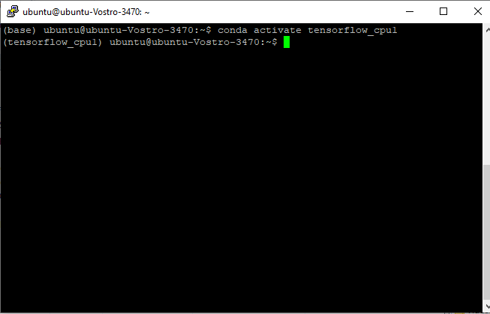

1. Install compatible tensorflow version

**pip install –ignore-installed –upgrade tensorflow==1.12**

1. Install required packages for SSD object model detection

**pip install pillow**

**pip install lxml**

**pip install jupyter**

**pip install matplotlib**

**pip install cython**

**pip install opncv-python**

1. **Annotating images**

To annotate images we will be using the [labelImg](https://github.com/tzutalin/labelImg) package

**conda create -n labelImg pyqt=4**

**activate labelImg**

**conda install pyqt=4**

**conda install lxml**

**pyrcc4 -py3 -o resources.py resources.qrc**

**python labelImg.py**

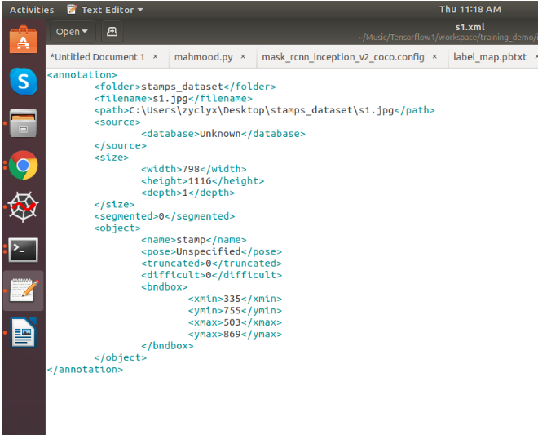

**6.Creating Label Map**

item {

id: 1

name: 'stamp'

}

Label map files have the extention .pbtxt and should be placed inside the training_demo\annotations folder.

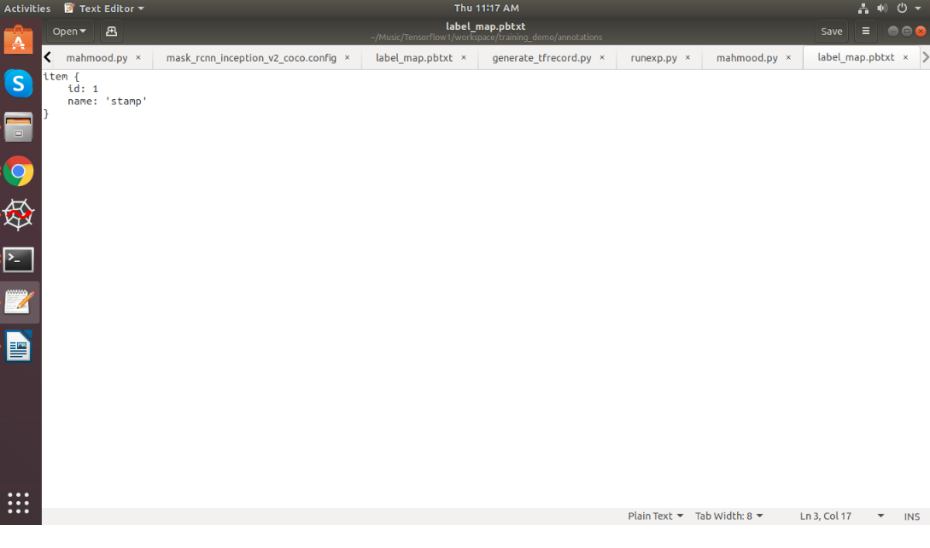

## 7. Creating TensorFlow Records

## 7.1 Converting *.xml to *.csv= *python xml_to_csv.py -i [PATH_TO_IMAGES_FOLDER]/train -o [PATH_TO_ANNOTATIONS_FOLDER]/train_labels.cs*

## 

7.2 Converting from *.csv to *.record= *# Create train data:* *python generate_tfrecord.py --label=<LABEL> --csv_input=<PATH_TO_ANNOTATIONS_FOLDER>/train_labels.csv --output_path=<PATH_TO_ANNOTATIONS_FOLDER>/train.record*

## There should be 2 new files under the training_demo\annotations folder, named test.record and train.record, respectively.

## 8. Configuring a Training Pipeline-

## The model we shall be using in our examples is the ssd_inception_v2_coco model, since it provides a relatively good trade-off between performance and speed. Since we shall be using the ssd_inception_v2_coco model, we shall be downloading the corresponding [ssd_inception_v2_coco.config](https://github.com/tensorflow/models/blob/master/research/object_detection/samples/configs/ssd_inception_v2_coco.config) file.

## 9. Training the Model

**python train.py --logtostderr --train_dir=training/ pipeline_config_path=training/ssd_inception_v2_coco.config**

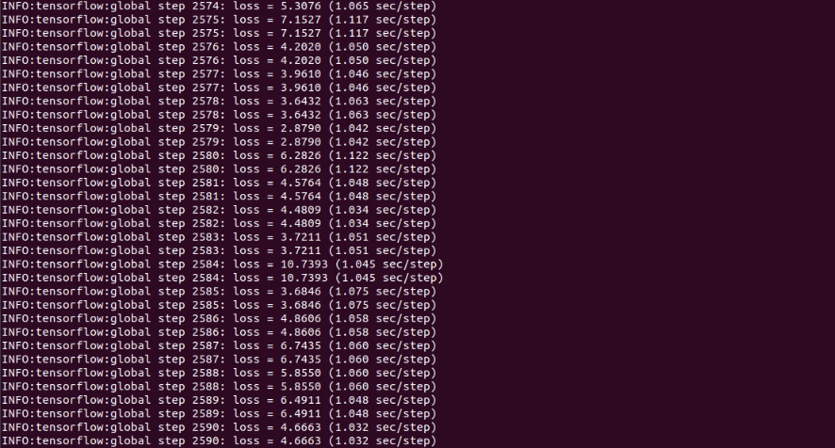

**OUTPUT of SSD model for stamp verification.**

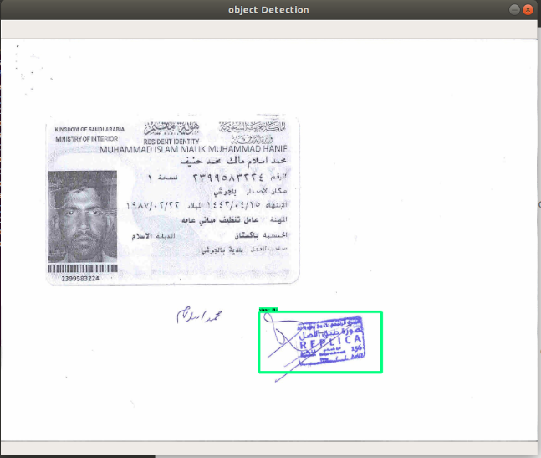

10.For training SSD custom object detection model go through this links

[**https://tensorflow-object-detection-api-tutorial.readthedocs.io/en/latest/training.html**](https://tensorflow-object-detection-api-tutorial.readthedocs.io/en/latest/training.html)

Installation / Dependencies needed for SSD Model

[**https://github.com/tensorflow/models/blob/master/research/object_detection/g3doc/installation.md**](https://github.com/tensorflow/models/blob/master/research/object_detection/g3doc/installation.md)